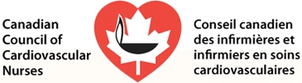
CCCN Mentorship Program
Retaining nurses into the workforce is a complex and multidimensional issue that has had significant study and attention over the past decade. From the literature, one theme has emerged: mentorship assists with engaging new nurses. Engaged nurses have a passion for their profession and the Canadian Council of Cardiovascular Nurses (CCCN) wants to cultivate that passion. We want to attract members that have a passion for Cardiovascular Nursing; after all we are the voice of Cardiovascular Nursing in Canada.
CCCN is looking to develop a formal mentorship program; where nurses new to Cardiovascular Nursing can seek guidance and support from the experts. This support can come in many forms, such as; phone conversations, emails, text, friending on social media and informal gatherings such as a CCCN meeting or a national conference. There are no formal terms, or contracts; just two registered nurses sharing a passion for cardiovascular nursing practice.
The Board of Directors is seeking your expertise. We would like you to be one of our senior mentors. Your commitment to CCCN as well as your expertise in the field of cardiovascular nursing have identified you as an exceptional candidate for mentorship. The time commitment can be as little or much as you feel you can provide, and will depend on the mentees needs. We will match mentors and mentees based on geographical similarities, fields of CV practice, and professional interests.
If you are interested, we would ask that you complete the demographic information attached. Please note your information will be kept confidential and only your name and email will be shared with the mentee.
The CCCN board of directors would like to thank you for your consideration and your courage.
With Courage;
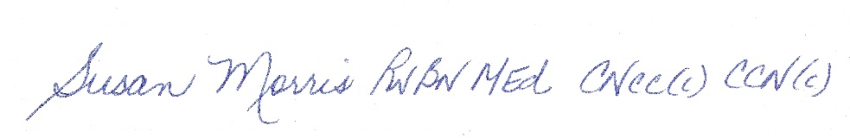
Susan Morris
President Canadian Council of Cardiovascular Nurses

Mentorship Program: Mentor Application Form

Name:

Application Date:

Mailing Address: | City: Prov: Postal code:
Email contact:

Phone: | ( )

Years of Cardiovascular Nursing:

Current position held:

Areas of CV nursing interest:

Short Bio:

