CCCN Mentorship Program
Mentee Application
Congratulations in taking the first step in what we hope will be a long and rewarding career in the field of cardiovascular nursing. The Canadian Council of Cardiovascular Nurses is the only official voice of Cardiovascular Nursing in Canada. We are a highly sought after group of experts who sit on the board of Hypertension Canada, and have strategic partnerships with the Heart Failure Network, Heart & Stroke Canada, Obesity Canada to name a few.
This group of nursing experts would like to broaden their reach and begin a formal mentorship program. This program is intended for nurses new to the field of cardiovascular nursing but is offered to any member of CCCN. The program is meant to ignite your passion for cardiovascular nursing and to assist you in succeeding in the field of cardiovascular nursing.
Being new to a specialty demands courage. Courage is “that little fire within” that leads us to take chances and seize opportunities, both personally and professionally. So now that your “little fire” has been ignited, CCCN would like to foster its’ growth in the form of a mentorship program. We invite you to complete the demographic information attached and forward it to Kathryn@cccn.ca
Within 2-3 weeks your mentee will contact you and she/he will begin the “getting to know you” process. The relationships that develop can serve to be beneficial to both of you: you receive the best CCCN has to offer and in return your mentor watches you grow and become a strong voice for cardiovascular nursing and an ambassador for the Canadian Council of Cardiovascular Nurses. We call this a win-win opportunity for all. Success is not measured in time but rather in relationships, we hope this program meets and exceeds your expectations.
With Courage;
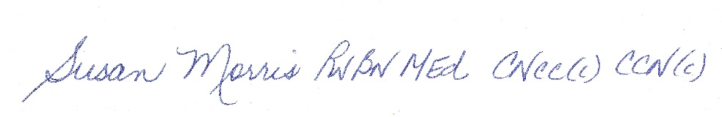
Susan Morris
President Canadian Council of Cardiovascular Nurses

CCCN Mentee Application Form
Name:

Application Date:

Mailing Address: | City: Prov: Postal code:
Email contact:

Phone: | ( )
Field of CV Nursing Practice:

Field of CV Nursing Passion if different from above:

Number of Months or Years as a Nurse:

Expectations of this program:

What is your biggest professional fear as a CV nurse?

Any personal information you would like to share (significant other, children, pets)

